

Effectiveness of marketing dollars by product type and across geographies

OPMT7750

Edsson Aragón + elijah Clare

A01162726 + A00158803

2020

# Executive Summary

The following visualizations depict the performance of the 3-year term sales dollars of a bicycle retailer with respect to the return on investment based on a specific set goal to fulfill a management objective. Years observed are from 2014 to 2016. This showcases the performance of sales breaking down into countries, quantity of units sold for each country, monthly sales of the observed 3 years, and its allocated budgets, totals per item categories and years with their grand total, Total sales Amount of the 3-year term, total incurred profit and the ROI Indicator.

The dashboard helps management to adjust tactics and consider a reference to improve the performance of the global sales and maintain a good relationship with stakeholders to whom are ought the financial returns to base on the KPI Indicator.

Additional questions were asked in the dashboard to reinforce or create new tactics to strengthen the sales in territories where countries experience the least selling performance (i.e. Canada) and how to cope with the standard highest purchasing territory to meet Return on Investment Goal based on budget.

The dashboard contains information about sales performance in Canada as the least selling territory with visualizations that compare to other countries.

# Problem Statement

The visualizations show the sales of accessories, bicycles and Clothing occurring in the years 2014, 2015 and 2016. Each month contains its marketing budget allocated and sales performed as well as its totals per year, per object category in a 3-year term and grand totals. The data also portrays the performance of the sales in regions within the United States and outside.

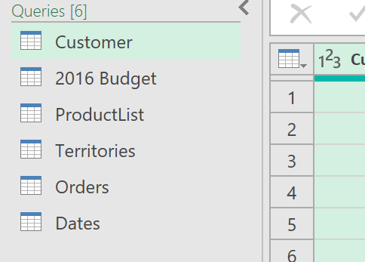Six tables were created and modelled for the creation of data visualizations: 2016 Budget, Customer, Dates, Orders, ProductList and Territories. The 2016 Budget table contains information about the allocated marketing budgets per day for each item category to be purchased in 2016. The Customer table contains sensitive information about each customer with an assigned code or Customerkey to identify eligibility of discounts based on if they are married, own a home or if they possess cars as per tax regulations in different jurisdictions of the selling countries. The Dates table contains information about the different days and months of the years 2014, 2015, and 2016 prior to its registration into the fact table and further data visualization depiction in the dashboard. Orders table contains the list of purchases as well as information about the order date, ship date, customer key, sales territory key, sales order number, sales order line number, order quantity, unit price, total product cost, total sales amount, tax amount and total profit; the table serves as our FACT table to calculate the behaviour of the sales (See Figure 2). ProductList contains information about the items as subcategories grouped as Categories and encrypted into Product Keys prior to represent them into the FACT table. Finally, the territories table contains information with its assigned encryption key number prior to the linkage with the fact table Orders (See Figure 2).

Figure Tables used in Power Query

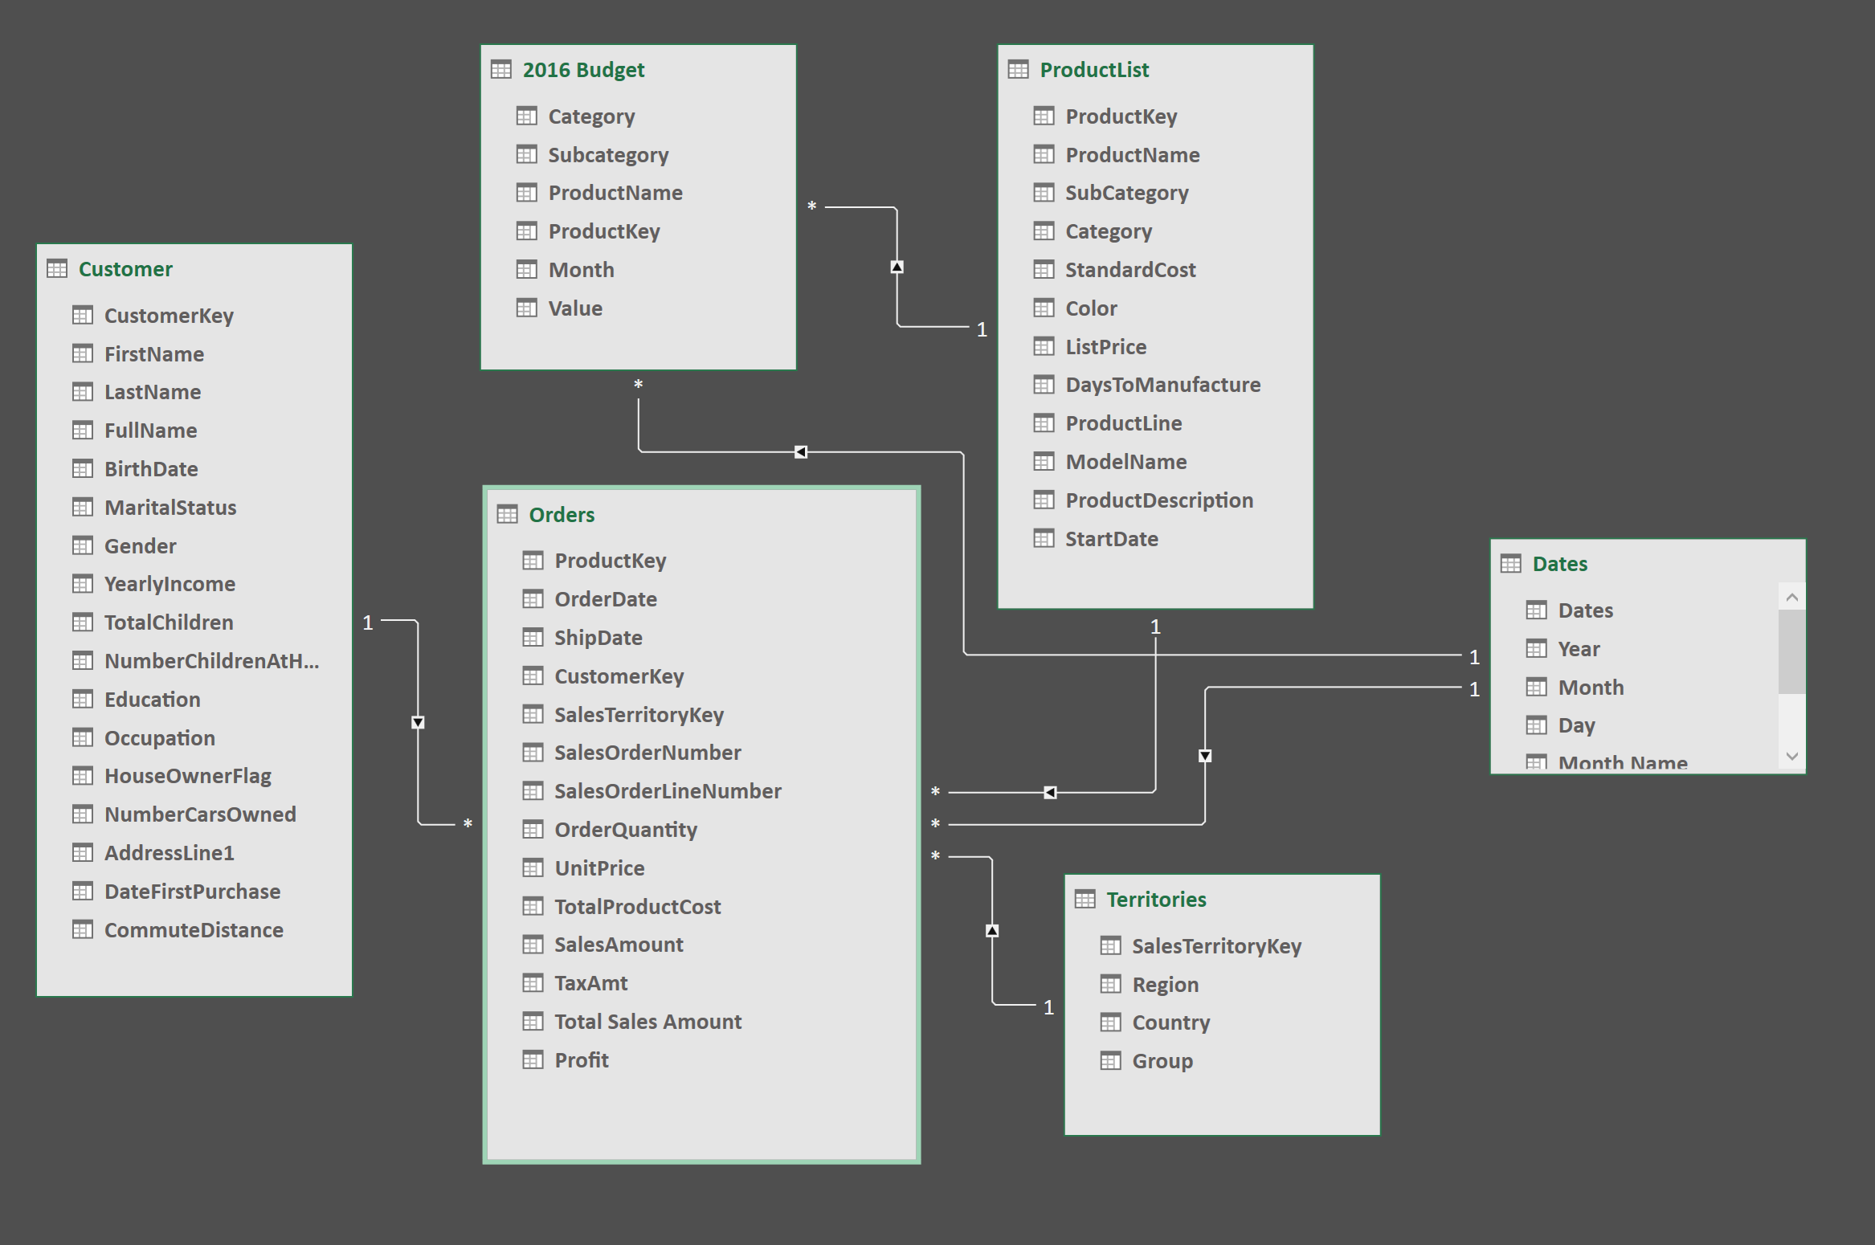

Figure 2 Relationships of the tables used to create a database. The Orders table is the Fact type due that it contains the information of interest prior to calculating ROI (Total Sales Amount)

The visuals in Figure 3 depict 7 attributes: The world map highlighting the countries where the items were purchased, the same countries’ graphical dominance of the sales in a tree map, the grand total sales amount of the 3-year term, the grand total of the profit, a table showing the 2016 target budgets allocated for each month and the sales incurred, a table broken down into years and item category with its respective totals and grand total and a Key Performance Indicator (KPI) of the Return of Investment (ROI).

The world map highlights entire countries despite the United States being divided by regions. Canada and the United States were the only countries in North America highlighted. France, the United Kingdom, and Germany were the only countries in Europe where the sales performed. Two other countries, Australia and Namibia were also highlighted. This visual indicates the countries where the items are sold and might indicate which other countries based on business tactics we should prioritize.

The Tree map depicts the countries where most items are sold regardless of item category. In this case, Australia leads the quantity followed by the American Southwest, Northwest, United Kingdom, Germany, France, and Canada at the end. Countries with the fewest sales are not shown.

Total Sales Amount and Total Profit are depicted as cards to illustrate the 3-year term profitability of the company.

Finally, we have the tables, which indicate the sales amount per month, year, and product. It includes grand totals in which one of which is also included as the Total Sales Amount number indicator.

The ROI, the most important measure to calculate the effectiveness of the marketing budget uses the following formula:

The whole formula is summed 1 to obtain the ratio multiplier instead of a percentage. Resulting 1 indicated a “Breakeven” return, less than 1 results in bad performance or negative ROI and more than 1 starts to give a healthy outcome. Nevertheless, the goal determined is a multiplier of 3 indicating a return of 3 dollars for every 1 marketing budget dollar which was not fulfilled according to the visual. A test number measure field written in DAX Code was added to verify the automatic change to a positive KPI number. The KPI indicator only contained green and red indicators representing goal met or failure.

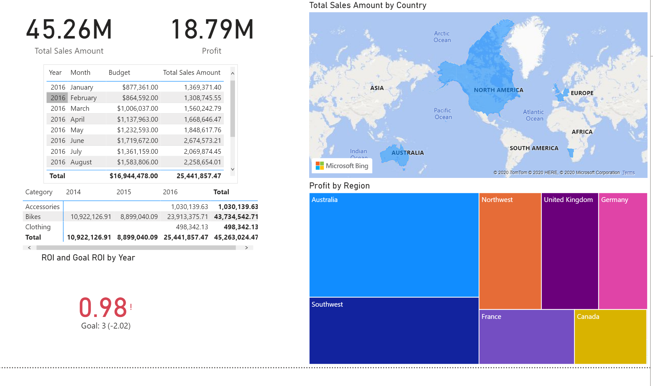

Figure 3 Power BI Dashboard depicting the information of worldwide sales and the strength of the Return of Investment as a Key Performance Indicator

# Resolution Summary

The current Return on Investment indicated the performance of the sales has not sufficiently met the established goal despite still being high in amount, one of the recommendations would include the assessment of how the company is spending the money, what they are advertising, to where, and to whom and which medium (i.e. Television, social medium, radio, podcasts, city adverts).

The dashboard in Figure 4 focuses only on Canada as the country where attention is needed the most compared to the other territories’ performance. Due that Canada is one of the countries where bicycle transit is considered instead of cars, management tactics employed should boost the sales within the country, so this will strengthen the profitability of the Canadian region and increase ROI. Nevertheless, tactics must meet the Marketing Budget previously established.

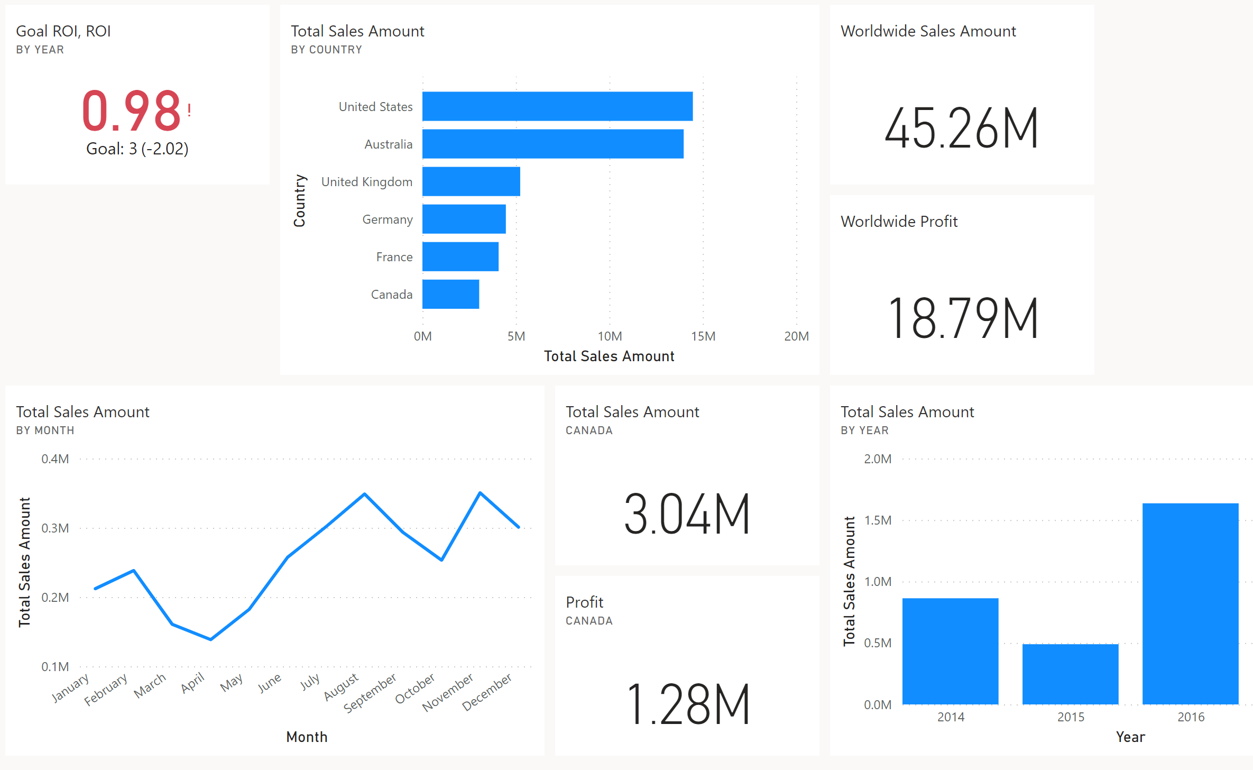

Figure 4 Dashboard of the sales performance in Canada